ASSIGNMENT – 5

1. Write a query to list all the tables in the dataset my_project.my_dataset.

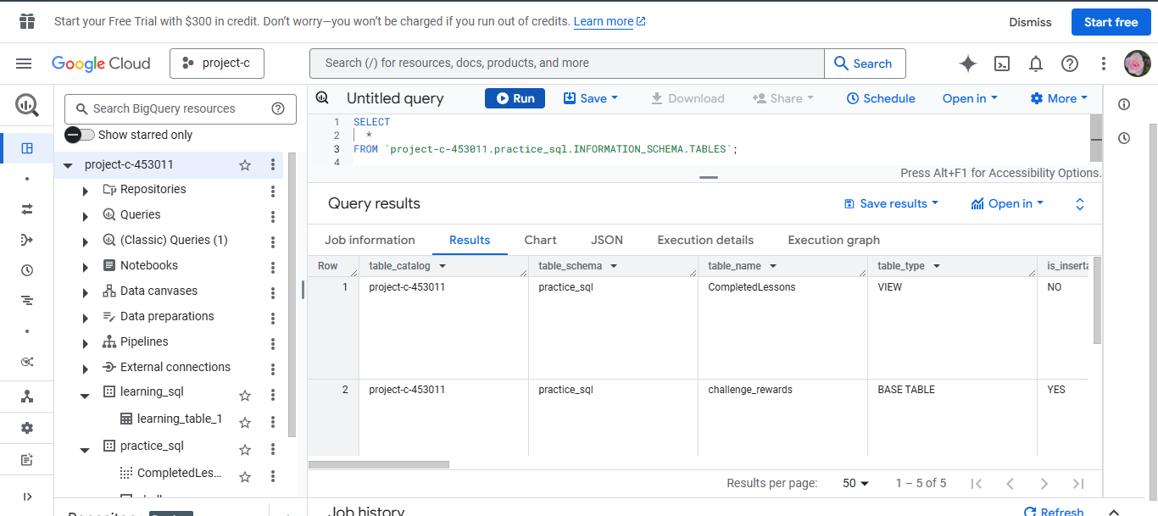

1. Write a query to get the column names, data types, and whether they are nullable, for the table my_table in my_dataset.

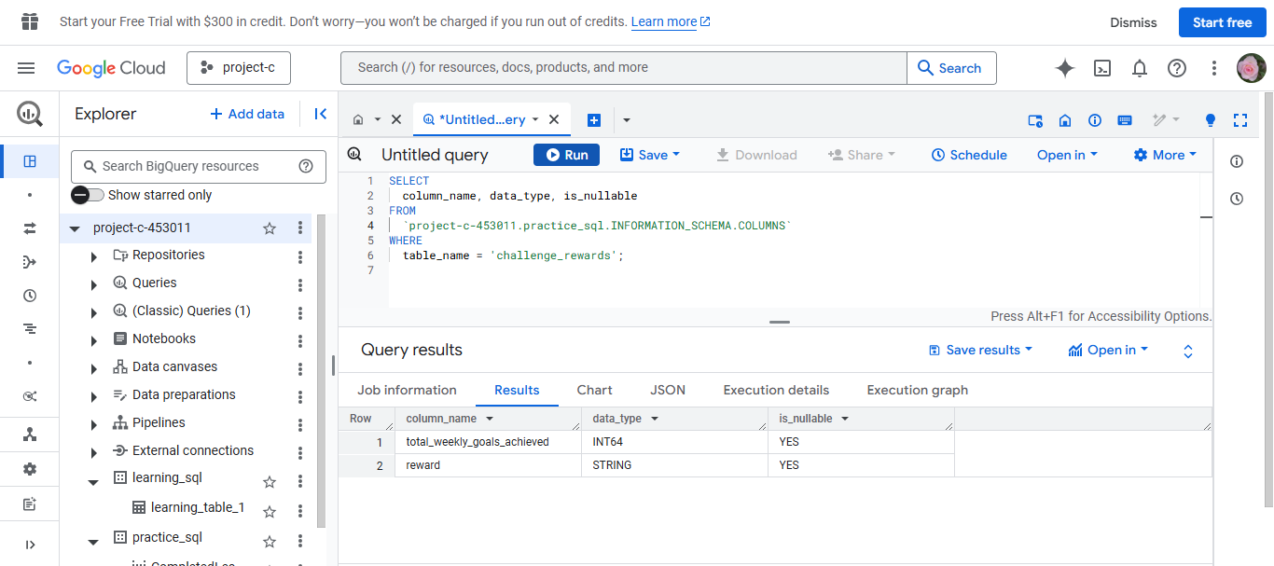

1. Write a query to list the tables that have been queried the most, based on the number of query jobs run in the dataset my_project.my_dataset.

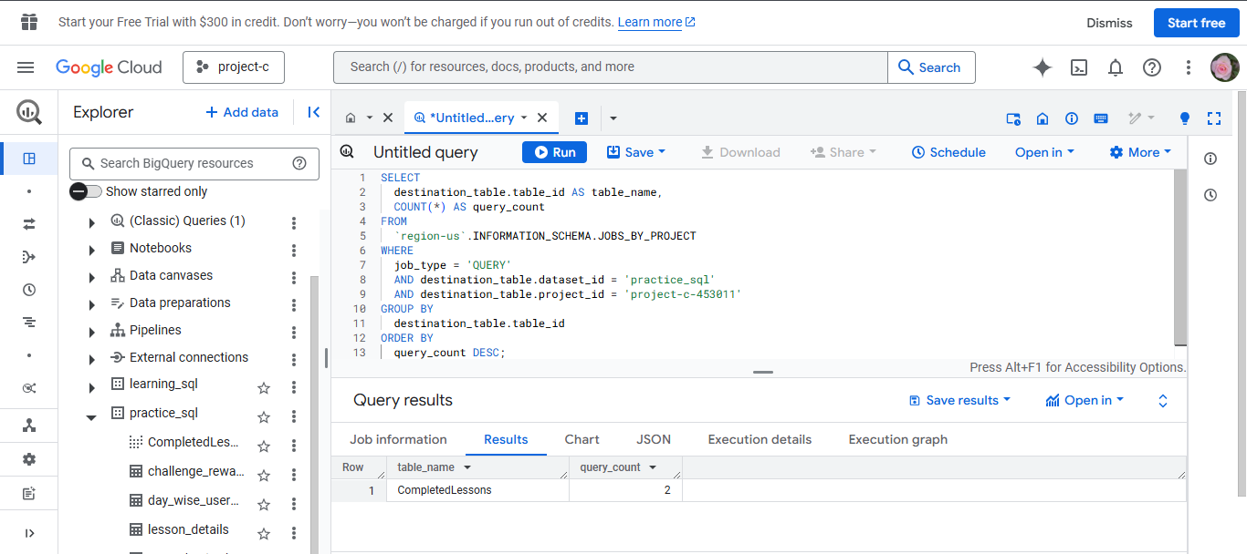

1. Write a query to find all tables in your dataset my_dataset that have zero rows.

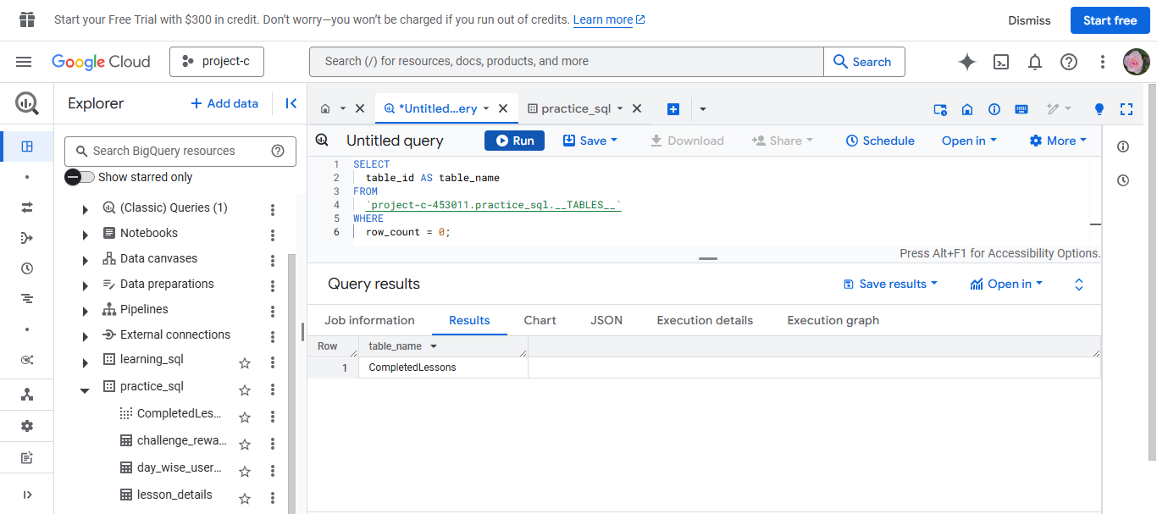

1. Write a query to list all the schemas in the project my_project.

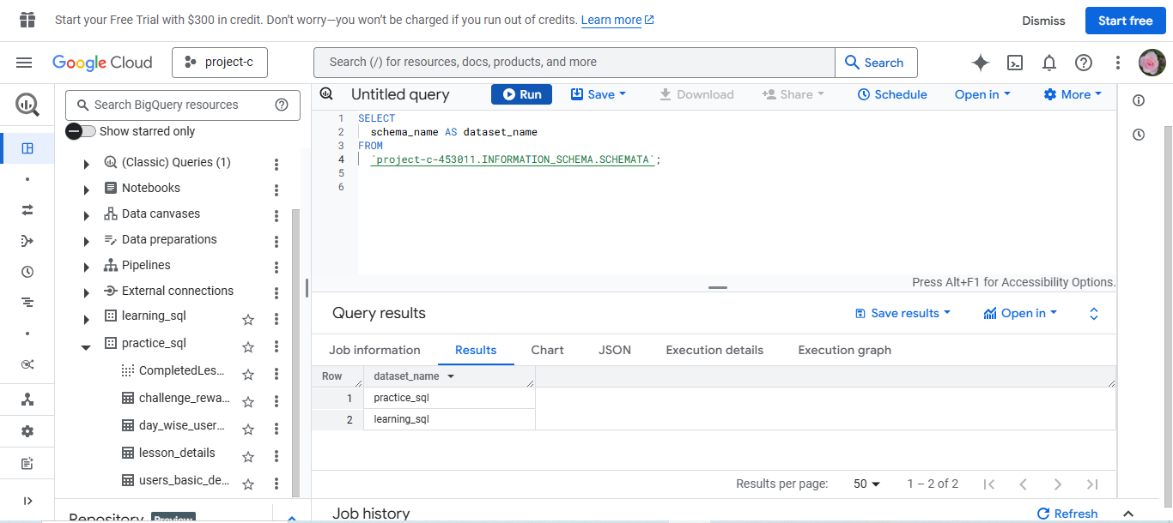

1. Write a query to list all views in the dataset my_dataset along with the creation time and view definition.

